**Analysis of location data pertaining to Iowa City, Iowa**

**Ryan Hazen**

**Problem Statement**

Claire wants to open a Yoga studio in the city where she attends college at the University of Iowa. The analysis performed in this report will look at the location data pertaining to the city of Iowa City, and hope to answer the questions of is there demand for Yoga in the city, how popular is Yoga in this location, how much competition might she have, and where in the city might be the best place for her studio considering these other points.

**Sources of Data**

The zip code data for the city of Iowa City and their corresponding latitude and longitude values were retrieved using Google Maps and its geolocation API

The venue data for the city and its zip codes were obtained using the Foursquare places API.

**Data Analysis**

The Iowa City zip code data was retrieved and loaded into a data frame to then be used to retrieve the venue data.

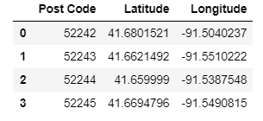

The zip code geolocation data was then used to retrieve the venues by zip code. The venue data was examined looking at the number of venue categories per zip code, and the number of unique venue categories across the data set. The zip codes of 52243 and 52244 are the more dense zip codes when it comes to venue categories. While 52242 and 52245 are the least dense.

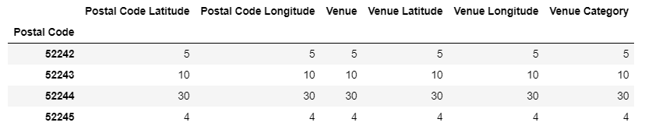

Across the entire area there are 41 unique venue categories.

Let’s look at the most common venues per zip code in the Iowa City area to get an idea of the popularity of different categories of venues in the various zip codes. The top most venue categories include Food, Food Truck, Coffee Shop, and Athletics/Sports

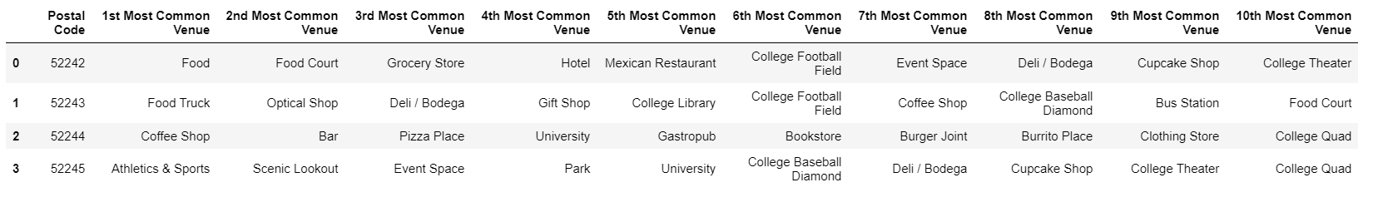

We can group each zip code into individual clusters and super impose them onto a map of the Iowa City area in order to get an idea of the areas surrounding each zip code.

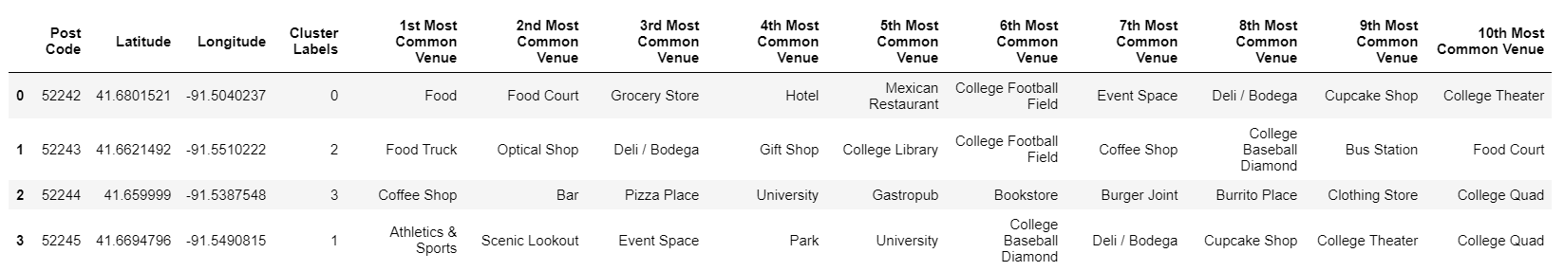

Once we lay the clusters onto the map of the city it gives us a better visual of each zip code and its surrounding area.

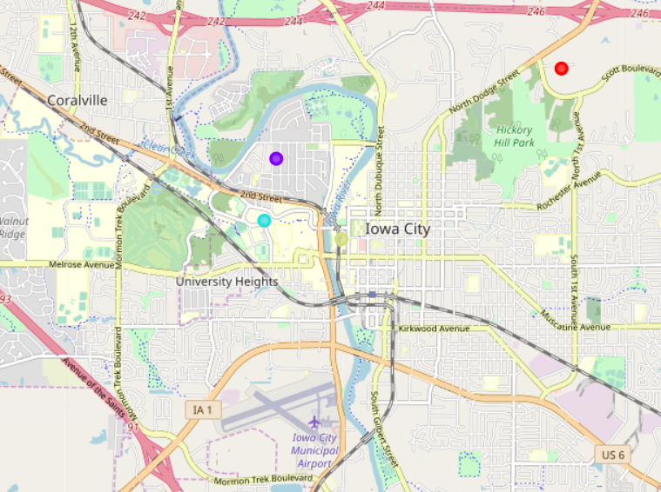

**Conclusion**

We set out to help Claire answer the question as to whether she should open a Yoga studio in the town of Iowa City. Looking at the data above Foursquare did not produce any Yoga studio venues for the zip codes located in Iowa City. This could help Claire decide if she wants to introduce a Yoga studio in a city where there doesn’t seem to be many or none at all. If there are no studios currently then there may be little or no competition from traditional Yoga studios in the area.

If the supply of Yoga studios is little than the next question she would have to answer would be regarding the demand for her Yoga studio services, and the location where the most interest may exist. Cluster 1 may be the most likely candidate considering some of the categories in the top four are Athletics/sports, scenic outlook, park, and university. Based on this cluster 1 seems to contain individuals that are more apt to participate in outdoor and physical activities, which align with living a healthy lifestyle.